New FSEA/Auxiliary Application Guide

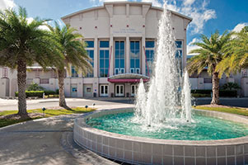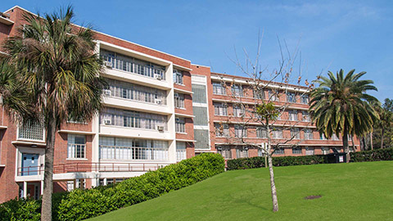

CONTENTS

**Introduction** 3

**What is a Fee-for-Service Educational Activity (FSEA)?** 3

**Information You’ll Need** 3

**How to Complete a New FSEA Application Form** 4

**Appendix** 6

**I.** **Section 2 Questions** 6

**Other Helpful Resources** 7

# **Introduction**

Auxiliary Accounting is launching a new electronic FSEA Application/Request to Operate Form to accurately document the general information and financial operating plan of new requests to establish Fee-for-Service Education Activities (FSEA) from University departments. The FSEA Application/Request to Operate Form is a new OnBase system form that works best with Firefox. A sample of the FSEA Application Form is available on our [Auxiliary Accounting Website](https://www.fa.ufl.edu/departments/auxiliary-accounting/).

This guide provides a brief description of what a Fee-for-Service Activity (FSEA) is, information you need to obtain before completing the form, and high-level steps for completing a New FSEA Application/Request to Operate Form in the OnBase system.

# **What is a Fee-for-Service Educational Activity (FSEA)?**

A Fee-for-Service Educational Activity is a revenue-generating activity that provides goods and/or services. Such activity enhances, promotes, or supports the University's instruction, research, public service, campus support functions, and other educational and support functions to meet the needs of students, faculty, staff, and members of the public participating in University events and programs.

# **Information You’ll Need**

Here is the information you should gather before completing the FSEA Application Form process:

* FSEA Rate Workbook ([link to spreadsheet](https://www.fa.ufl.edu/directives/creating-a-fee-for-service-educational-activity/)). The Excel FSEA Rate Workbook assists the unit in providing details about the financial plan, target customer(s), type of service lines, and projected operating revenue and expenses of the FSEA activity to calculate the service lines rates.
* Guarantee ChartField string of the funding source that will cover any recurring losses of the FSEA.
* Approval from highest accountable administrators of your college.
* Any additional supporting documentation for the proposed FSEA activity, such as market rate comparisons, descriptions of the activity processes, capital equipment (cost>$5000) to be utilized 100% in the FSEA activity, etc.

# **How to Complete a New FSEA Application Form**

This section describes the steps for completing the main areas of the new electronic Fee-for-Service Educational Activities (FSEA) Application/Request to Operate Form.

1. Visit our [Auxiliary Accounting Webpage](https://www.fa.ufl.edu/departments/auxiliary-accounting/) to submit a **New FSEA Application/Request to Operate Form**.
   * GatorLink authentication is required to access the FSEA Application online form.
2. Read the introduction of the electronic FSEA Application Form before completing the sections of the form.
   * The introduction of the form provides general information and instructions you need to follow to complete the form.
3. Complete all the sections of the FSEA Application/Request to Operate Form.

**FSEA Application form Sections:**

* **Section 1: Unit Contact Information**
* **Section 2: General Information**
* **Section 3: Department Approvers**
* **Form Submission**

1. Enter all applicable FSEA Unit Contacts in **Section 1.**
   * Enter your UFID form in the **Requestor** information.
     + The contact information will auto-populate once you enter the UFID in the **Requestor** section.
     + Click on the "**Clear Requestor Information"** to update the **Requestor’s** UFID.

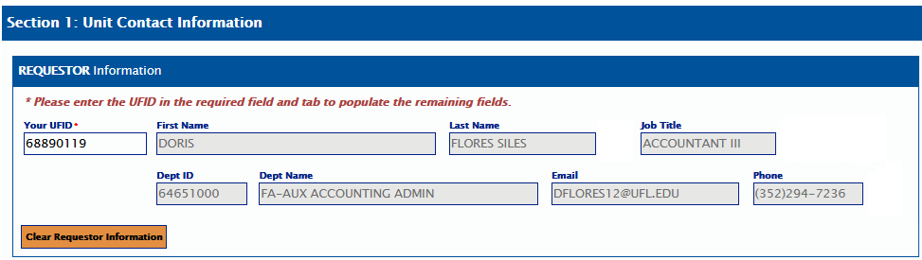

* + Select one or two people responsible for **overseeing the** **day-to-day operations** of the unit.
    - Search by **Last Name** to complete the **Primary/Secondary Operational** contacts.
    - The **Secondary** contact is an optional field and can be blank.
  + Select one or two people **responsible for the** **day-to-day accounting activities**.
    - Search by **Last Name** to complete the **Primary/Secondary** **Fiscal, Director, and Lab Manager** contacts.

1. Complete all applicable questions **1 through 12** from **Section 2** of the form.
   * The **General Information** section assists the Auxiliary Accounting office in identifying general FSEA operational information updates needed and allows the unit to document the rate calculations.
   * In question number 12, attach the completed [**FSEA Rate Workbook**](https://www.fa.ufl.edu/directives/creating-a-fee-for-service-educational-activity/) under the **FSEA Rate Form section and any supporting documentation.** You cannot submit the form without the **FSEA Rate Workbook** (required field).
   * For details of all the 12 questions from **Section 2**, please review the [**FSEA Application Sample Form**](https://www.fa.ufl.edu/directives/creating-a-fee-for-service-educational-activity/) available on our [Auxiliary Accounting website](https://www.fa.ufl.edu/directives/creating-a-fee-for-service-educational-activity/) or in **Appendix I** (Section 2 Questions) from this document.
2. Enter the approvers or highest accountable administrators who will certify/recommend the approval of this request under **Section 3**.
   * Search by **Last Name** to complete the **Department Chair/Director** Approver **and Dean/Vice** **President** Approver contacts.
     + The **Department Chair’s** contact must be different from the **Dean/VP**.

1. Complete all **required** FSEA Application/Request to Operate Form fields before submitting it.
2. Submit the FSEA Application Form for approval.
   * After submitting the form, you will receive a thank you email with a link to the form for future access if needed.
   * The form will first be routed to the Auxiliary Accounting office for a preliminary review and then routed to the department’s approvers for approval.
   * For the complete FSEA Application approval process description, please visit our Auxiliary Accounting Website under the [Basic Approval Process](https://www.fa.ufl.edu/directives/basic-approval-process/) page.

**Remember**

* Once you initiate the FSEA Application/Request to Operate Form, you can save it for later.
* Your Single-Sign-On authentication will **time out after 20 minutes** of inactivity. Be sure to **save** your form if you cannot complete and submit it without a 20-minute delay, or **you will lose your progress**.
* When you save your form for later, you will receive an email with a **link** to return and complete it.

**If you need assistance, please email** [ga-aux@ad.ufl.edu](mailto:ga-aux@ad.ufl.edu)**, or call (352) 294-7236, or visit our** [**Auxiliary Accounting Website**](https://www.fa.ufl.edu/departments/auxiliary-accounting/) **for additional information.**

# **Appendix**

## **Section 2 Questions**

1. **Proposed Unit Name?**

* This will be used as a guide for the future naming of the Fee-for-Service Educational Activity, if approved.

1. **Physical Address of Proposed Unit (do not use a P.O. Box)?**
   * Enter the Building Number, Building Name, Floor #, Room Number, Additional Location.
   * List all locations where the goods/services will be provided in the **Additional Location** box.
2. **Describe the proposed Fee-for-Service Educational Activity?**

* The description of the FSEA activity is a narrative of what the unit does and which goods/services it offers customers.

1. **Describe how the proposed activity supports the mission of the University of Florida.**
2. **Select an Activity Type Category** from the drop down menu based on the FSEA’s Activity description and type of goods/services.
   * Contact the Auxliary Accounting Team for assistance in identifying the best Activity Category for the FSEA Activity.

1. **Does another unit of the University already provide a same/similar service?**

**6a. Please explain the necessity/uniqueness of a proposed FSEA service, if it already exists on campus.**

1. **Do you plan to charge grants?**

**7a. Please describe who your proposed sponsored activity would be with.**

1. **Do you propose to have sales with External Customer?**

**8a.** **Please provide a narrative that explains how the service meets the following criteria:**

--- The service is not readily available outside the University.

--- The service has a research purpose or helps educate students.

--- The service does not compete with the private sector

**8b**. **How will any potential excess revenues from external customer be spent?**

1. **Specify a Guarantee Chartfield that will cover any recurring losses of the FSEA. Enter the Fund # and Department ID #.** 
   * The Dept Name will auto populate once the Dept ID # is entered
2. **How will the department make rates available to the UF Community? (Specify website, etc.)**
3. **List the Website URL for this FSEA activity (or Enter “N/A”)**
4. **Attach Proposed Rate Documentation (required) and any other supporting documentation - A template form is available here**: [(link to spreadsheet)](https://www.fa.ufl.edu/directives/creating-an-educational-business-activity/)

# **Other Helpful Resources**

1. [Creating a Fee-For-Service Educational Activity](https://www.fa.ufl.edu/directives/creating-a-fee-for-service-educational-activity/)
2. [FSEA Application Sample](https://www.fa.ufl.edu/directives/creating-a-fee-for-service-educational-activity/)
3. [Basic Approval Process](https://www.fa.ufl.edu/directives/basic-approval-process/)
4. [Setting up a Fee‐for‐Service Educational Activity](https://www.fa.ufl.edu/directives/setting-up-the-approved-fsea/)